**NGF COLLEGE OF ENGINEERING AND TECHNOLOGY, PALWAL (HARYANA)**

**PROJECT SYNOPSIS**

**ON**

**INGFCET Pizzeria**

**Submitted By**

**Ishwa**

**B. tech (CSE 3rd Year)**

**6th Sem**

**S19CSE022**

**Submitted To**

**Ms. Sonu Sharma**

**Assistant Professor**

**SYNOPSIS ON PROJECT**

**INGFCET Pizzeria**

**Introduction**

The INGFCET Pizzeria System helps the canteen manager to manage the college canteen more effectively and efficiently by computerizing meal ordering, billing and inventory control. This management system is designed for a college Canteen. The system processes transaction and stores the resulting data. Reports will be generated from these data which help the manager to make appropriate business decisions for the canteen.

This will help the canteen owner in many ways such as ordering goods, inventory control, generating bills, managing tables, managing menus, and various customer services.

**Objective**

This objective of the project is

* To update current canteen systems.
* To update current canteen systems.
* To simplify and make it easier to manage.
* To control every records of canteen.
* To manage all the stock.
* To check or view every details of canteen.

**E-R DIAGRAM**

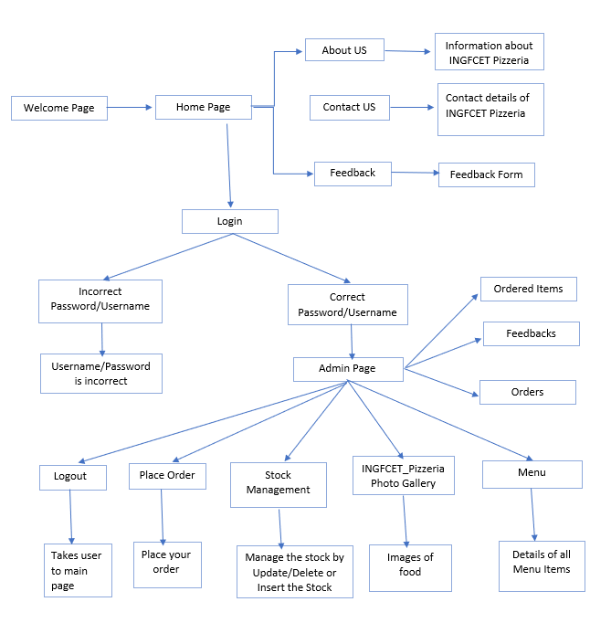

**Hardware Requirement:**

|  |  |
| --- | --- |
| Processor Brand | : Intel |
| Processor Type | : Core i5 |
| Processor Speed | : 2.40 GHz |
| RAM Size | : 8.00 GB |
|  |  |

**Software Specification:**

Operating system : Windows 10

Application server : JAVA (NetBeans)

Front end : JAVA

Database connectivity : XAMP (MYSQL Console)

**Content**

* Welcome Frame
* Home Frame
* About Us Frame
* Contact Us Frame
* Login Frame
* Admin Frame
* Stock Management Frame
* Order Frame
* Feedback Frame

**Future Scope**

1. Can be link to many food delivery websites like Zomato to increase business.
2. We can print bills of the orders.
3. Can be link to google map location features in future for fast home delivery service.
4. We can add online payment options for fast and secure payment of orders.

**Conclusion**

The INGFCET Pizzeria System helps the canteen manager to manage the college canteen more effectively and efficiently by computerizing meal ordering, billing and inventory control. This management system is designed for a College Canteen. The system processes transaction and stores the resulting data. Reports will be generated from these data which help the manager to make appropriate business decisions for the canteen.

This will helps the canteen owner to modify the menu easily, deduct the waiting time, helps to make life easy as the canteen by tracking all sales data, by reducing the errors, enhanced and effective Use of Human resources

Helps the canteen owner to free up the staff from performing time-consuming tasks.

**REFERENCE**

<http://peperoni.com.sg/>

[www.google.com](http://www.google.com/)

[www.youtube.com](http://www.youtube.com/)